**Process For Researching**

Notes

* Try not to spend more than 5 minutes researching each contact.
* The columns are listed by priority, your first priority is to find Email Address followed by: Phone, Web Form, LinkedIn, Twitter, Facebook and Google+
* Column A is a duplicate check formula for Author Name,if the author is a duplicate then delete the row
* Here is an example: <https://drive.google.com/open?id=1G9LhzVf1f5oxD2cEGvom4wZ_GsQ31q9uf12Ie0vp9Pc>

**1. Click the URL and follow the link to the website**

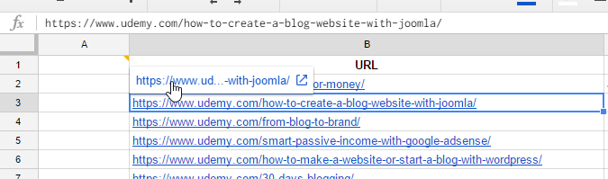

**2. Scroll down and copy the name of the instructor**

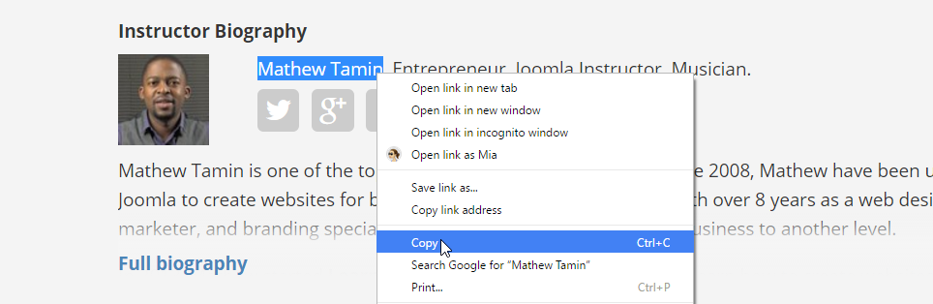

**3. Paste the name of the instructor next to the URL in the spreadsheet**

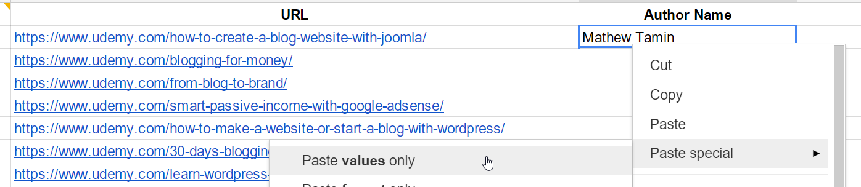

**4. Return to the instructors page and follow the link to his personal site. Note: if   
 the link does not exist then try searching google for the Instructor name**

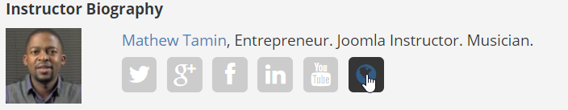

**5. If the website has a contact form, copy and paste the web address into the   
 Contact Form column on the spreadsheet**

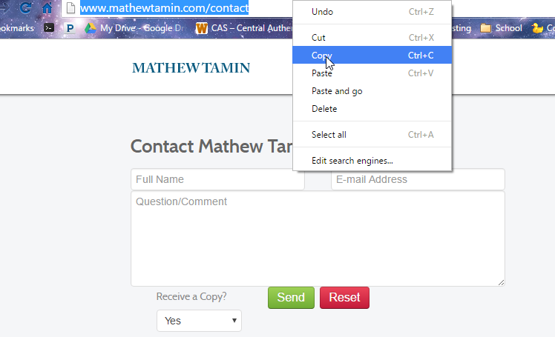

**6. Copy the websites base domain**

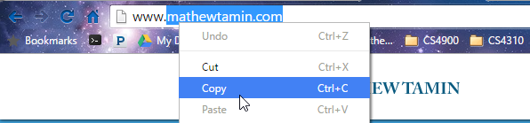

**7. Paste the domain into** [**http://website.informer.com/**](http://website.informer.com/)**. Note: if results appear to be   
 incorrect try** [**https://whois.icann.org**](https://whois.icann.org)

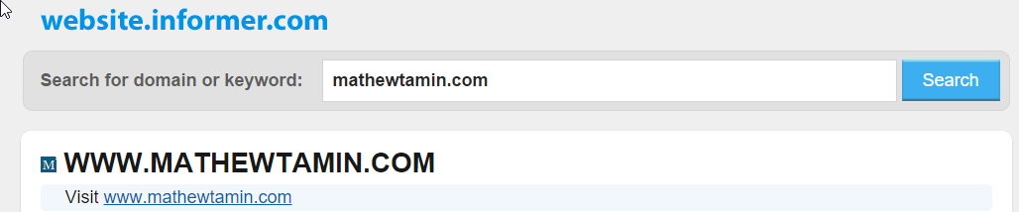

**8. Search through the WHOIS data for the domain and locate and copy the users   
 email and paste into the Email column**

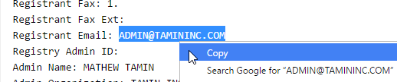

**9. Find and copy the user's 10 digit phone number and paste into the Phone   
 Number column**



**10. Return to the instructors page. For LinkedIn, Twitter, Facebook and Google+   
 right click and then “Copy link address”**

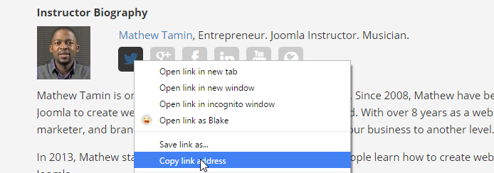

**11. Paste each of the links into the appropriate columns on the spreadsheet**



**12. Repeat these steps for each URL on the spreadsheet, if you cannot find   
 something for an Instructor then leave it blank and move on to the next.**